

Request for Proposal
Court Web Collections

Maureen Niebruegge
Procurement Specialist, Global Procurement
RELX Group plc
3251 Riverport Lane

Maryland Heights, MO 63043
Email: m.niebruegge@relx.com
Website: www.relx.com
Contents
Introduction……………………………………………………………………………………………………………………………. 3
RFP Timeline – Estimated………………………………………………………………………………………………………….. 4
Overview…………………………………………………………………………………………………………………………………. 5
Acceptance criteria of the deliverables……………………………………………………………………………………….. 6
Quality control and Methodology……………………………………………………………………………………………… 6-7
Project Volume……………………………………………………………………………………………………………………… 8-9
Pricing…………………………………………………………………………………………………………………………………… 10

About this RFP

LexisNexis Risk Solutions Group (Global Data and Analytics Provider - Subsidiary of RELX Group. RELX Group is a global provider of information and analytics for professional and business customers across industries) is seeking collaboration for services to collect data manually from court websites and in offering efficiencies for collecting data.

Definitions

“Backlog” means any data that is not up to date or present in the Oklahoma City database.
“Case Lead List” (AKA Case Number Lead List) means the Lead List requiring a search by case number to collect case details such as charge information or case disposition.
“Lookback Collection” means the collection of cases that are considered less than 7 years old which can be located by selecting the criteria, defined by LN, at website.
“Name Lead List” means the Lead List that requires a search by case name(s) and filing date search to collect a list of case numbers.
“NVS Lookback Collection” means the collection of National Violation Search (NVS) cases that are considered less than 7 years old which can be located by selecting the criteria defined by LN at court website.
“Search” means the unit of measure that will be used for pricing including all the tasks required to populate the search screen, to download the data from the website and to save the file from the website for each Lead List.

RFP Timeline – Estimated

Deadline Dates | Tasks
May 5 | RFP kick-off: Document sent via email to suppliers from Maureen Niebruegge @RELX Procurement
May 8 | Q&A via Email to m.niebruegge@relx.com  Service Provider makes use of MA – Massachusetts Courts Case Access and MA – Massachusetts Daily Docket leads to search site per instructions to assess collection process and submit proposal to m.niebruegge@relx.com  Please note that returning samples is not required at this time.

Overview

The goal of the assigned Project is for Service Provider to search and capture the required information from Court websites with the details to be provided by LN. Due to Court restrictions, manual collectors are required to perform the searches to conduct searches for this information.

Service Provider will use their application to conduct Searches for the assigned Name Lead List according to LN collection instructions.

Project Scope

- The scope of this RFP is the web collection for MA - Massachusetts Courts Case Access (MAMUCWC) and MA – Massachusetts Daily Docket (MAMUDDK)

- Service Provider shall use their proprietary application to conduct Searches for the Collection according to LN instructions contained in the collection instructions to assess the effort involved using the Word document attached to the email invitation and estimated RFP timeline

- Complete the status for case found or case not found for the lookback collections into the Lookback Status returnfile template

LN Supplied Materials

      - *The Lead List for the Service Provider to perform the required Search
Collection instructions which provide the unique requirements needed for MA - Massachusetts Courts Case Access and MA – Massachusetts Daily Docket (MAMUDDK)
      - Lookback Status returnfile templates
      - MA - Massachusetts Courts Case Access returnfile template
      - MA – Massachusetts Daily Docket returnfile template

Deliverables

Excel file per the data map and field instructions found in the court collection instructions. Excel file to return status found and not found Lookback per sample template.

*Samples are not required at this time.

Delivery Location

Deliver any RFP documentation required to Maureen Niebruegge – m.niebruegge@relx.com

Acceptance criteria of the deliverables
Service Provider shall deliver to LN, completed, accepted Project Deliverables in accordance with the Service Levels outlined for each of the assigned Projects.
Service Provider is responsible for reworking its errors at no cost to LN.

Quality control and Methodology

Quality Methodology

Service Levels

Overall Standards

Service Provider shall provide the Services so as to meet or exceed the Service Levels for Accuracy requirements, and the Turnaround Time and Productivity Standards in accordance with this Section.

LN shall be responsible for measuring and reporting the performance of the Services against the applicable Service Levels on a monthly basis.

Accuracy requirements

• The Accuracy target requirement for this Project is 97 % Accuracy, one-pass keying.
• Service Provider is expected to meet the Accuracy Requirements outlined below as well as any future updates thereto.
• Accuracy will be calculated based on the following formula:

Accuracy = Total Lead Lists audited – Total Lead Lists Failed
Total Lead Lists audited

Example 1: 25 Lead Lists are audited. 0 Lead Lists Fail:
= 25– 0
25= 100%
Result: Output File PASSED

Example 2: 25 Lead Lists are audited. 3 Lead Lists Fail:
= 25 – 3
25
= 88%
Result: Output File FAILED

Turnaround Time and Productivity Standards

• LNRS shall specify the Turnaround Time for each Lead List assigned to Service Provider

• This estimate is based on average monthly volumes divided by 20 Working Days per month.

- Adherence to Turnaround Time and Productivity Standards will be audited as follows:

- LN will audit 25 random cases on a weekly basis.
- The LN audit feedback will be provided to Service Provider for the purposes of future improvement.

Definition of Quality Failures
Accuracy Failures

• The following types of errors shall be considered Accuracy failures:

- Incomplete Lead List collection
  - Leads sent but not returned
  - Leads identified as no hit on the court site

Project Volume

• The estimated Project volume will be provided for each Court.
- Estimated volumes may be based upon LN historical records or Court statistics. LN does not commit to ensure that these volume projections will be consistently met.

The estimated Project volume for MA – Massachusetts Courts Case Access

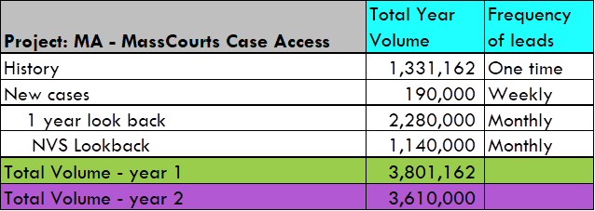

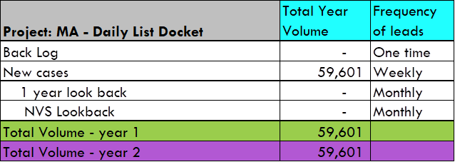

Pricing

Please complete MA - Massachusetts Courts Case Access proposal pricing and include assumptions around pricing per the preferred method of Service Provider, i.e. Acrobat, PowerPoint, etc. by email to m.niebruegge@rex.com

